
University of Brighton Computing Division
___________________________________________

CI505 Introduction to Functional Programming
By: Arielli Ortega
Student ID: 24837448
Date of Submission: January 15th, 2026

Library Management System
https://github.com/iamarielliortegaa/LibraryManagementSystem
Table of Contents
Introduction 3
Project Overview 3
Project Scope and Objectives 3
Development 4
Project Component Overview 4
Command-Line Interface Functionality 4
Functional Principles 7
Immutability 7
Testing Phase 10
Test Approach and Scenario Coverage 10
Book/User Management Tests 10
Borrow/Return Transaction Tests 10
Critical Review 11
Strengths: 11
Designing software with strong modularity and clean architecture. 11
Ensuring robust validation and reliability in my code. 11
Thoroughly testing my systems to ensure correctness. 11
Applying functional programming principles effectively. 11
Areas of Improvement: 12
Conclusion 13
Estimated Grade 13
References 14

Introduction
This project focuses on the design, development, and testing of a library management system tailored for small community libraries. Implemented in Haskell, the system leverages the strengths of functional programming to deliver a modular, extensible, and efficient solution. The primary objective was to create a lightweight yet robust application that demonstrates how functional paradigms, such as immutability, type safety, and separation of concerns, can be applied to real-world software engineering challenges.

Project Overview:
The application provides a command-line interface for operators to manage core library operations. Structured user input is parsed to support tasks such as adding books, registering users, listing available or borrowed resources, and handling borrowing and returning transactions. The system maintains dynamic inventories of both books and users, ensuring accurate state management throughout interactions.

Project Scope and Objectives:

The scope of this project includes building a library management system capable of handling book and user data, processing borrowing and return transactions, and providing an intuitive command-line interface (CLI) for operators. The objectives were as follows:
- Develop a modular architecture separating business logic from the user interface.
- Ensure data integrity through immutability and type safety.
- Implement comprehensive unit tests to validate all core operations.
- Demonstrate Haskell's functional programming paradigms in practical use.

Functional Programming Motivation:
Haskell, as a pure functional programming language, offers several benefits that informed the design of this project. Its emphasis on immutability ensures that data cannot be inadvertently altered, increasing reliability and predictability. Strong static typing helps prevent runtime errors and enforces correctness. Pure functions guarantee referential transparency, which simplifies code reasoning and testing. Finally, higher-order and recursive functions provide elegant solutions for complex list-processing tasks.

Overview of Implemented Functional Paradigms:
The system integrates key functional paradigms, including:
- Immutability: All data structures (books, users, library) are immutable. State changes produce new instances rather than modifying existing ones.
- Pure functions: Core operations (add, remove, borrow, return) are implemented as deterministic pure functions.
- Higher-order functions and recursion: Functions such as printBooks use recursion and higher-order constructs for iteration and data processing.

Learning Outcomes Alignment
All the planned module learning outcomes are covered in this report. The written report's professional presentation, clear structure, and critical reflection satisfy LO1. The proper implementation of fundamental functional programming principles, such as immutability, pure functions, and strong static typing, demonstrates LO2. The design and implementation of a modular library management system that uses functional principles to address a practical issue satisfies LO3. The creation of thorough automated tests, validation logic, and a thoughtful assessment of the system's advantages, disadvantages, and potential areas for development serves as proof of LO4.

Development

Project Component Overview:
The overall functionality of the system is achieved through a clear separation of concerns between two core components:

Figure 1: Architecture diagram showing the interaction between Main.hs (UI layer) and Library.hs (domain logic layer).

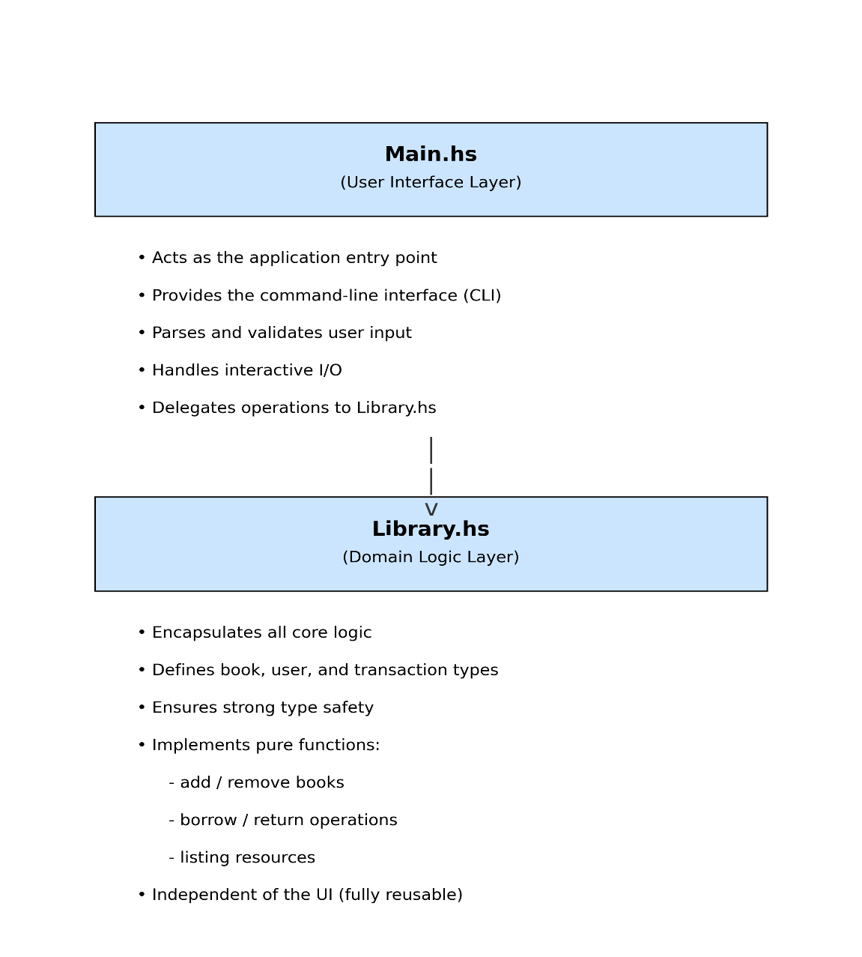

Command-Line Interface Functionality
Operators can interact with the system using commands to:
- Add or remove books.
- Register or remove users.
- List available and borrowed books.
- Borrow or return books. The CLI validates inputs, communicates errors, and ensures a seamless user experience.

The Library part contains the following,
- Status data type with two possible values as (Available / Borrowed)
data Status
= Available
| Borrowed deriving (Eq, Show)
- Book data structure which holds book ID, title, author, status and borrower name. The borrower name variable stores the name of the user who borrowed the book, assuming the book's status is Borrowed.
data Book = Book
{ bookId :: Int,
title :: String,
author :: String,
status :: Status,
borrowerName :: Maybe String
} deriving (Show, Eq)
- User data structure, which holds the user ID and name.
data User = User
{ userId :: Int,
userName :: String
} deriving (Show, Eq)
- Library data structure is a master data holder which holds a list of books and a list of users available in the library. The structure also stores two helper fields to track book and user counts, so the ID of a newly created book or user can be assigned.
data Library = Library
{ books :: [Book],
users :: [User],
bookCount :: Int,
userCount :: Int
} deriving (Show, Eq)

- addBook function is a pure business logic which performs adding a new book to the list of books inside the library object and returns the updated library object.
addBook :: String -> String -> Library -> Library
- removeBook function is a pure business logic which performs removal of a book by attempting to find the book by its corresponding book ID. If the book is found, then it will be removed. If book ID is not found, then it will return appropriate message.
removeBook :: Int -> Library -> (Library, String)
- availableBooks is a function which prints the list of books which have a status Available. The function internally uses another function to print a list of provided books.
availableBooks :: [Book] -> IO ()
- borrowedBooks is a function which prints the list of books which have a status Borrowed. The function internally uses another function to print a list of provided books.
borrowedBooks :: [Book] -> IO ()
- addUser function is a pure business logic which performs adding a new user to the list of users inside the library object and returns the updated library object.
addUser :: String -> Library -> Library
- removeUser function is a pure business logic which performs removal of a user by attempting to find the user by its corresponding user ID. If any book has been borrowed by the user (one or more), then the user will not be removed. If user ID is not found, then it will return appropriate message.
removeUser :: Int -> Library -> (Library, String)
- printUsers is a function which prints the list of users in the library.
printUsers :: [User] -> IO ()
- borrowBook is a function which takes a user ID and a book ID to be borrowed. User ID and book ID validation will be performed by checking whether either ID is unavailable; if so, the corresponding message will be returned. The book's status will also be verified. If the status is Borrowed, a corresponding message will be returned. If the book is available and the user is valid, the book status will be updated to Borrowed, and the user's name will be assigned to the book's borrowerName.
borrowBook :: Int -> Int -> Library -> (Library, String)
- returnBook is a function very much similar to borrowBook, but where, instead of assigning the book status as Borrowed, the Available status will be set, and the borrowerName of the book will also be cleared.
returnBook :: Int -> Int -> Library -> (Library, String)

Functional Principles

Immutability
The data structures created in the project are, by default, immutable. The Status data type we made will be a custom type whose possible values are defined during the data structure's definition.
data Status = Available | Borrowed deriving (Eq, Show)
Similarly, the data structures for users and books have also been defined, along with their members. The user data structure will contain the user ID and the user name. The book data structure will contain the book ID, title, author, status, and borrower name. Each of those types is either integer or string-based, depending on its purpose.

Figure 2. Illustration of code base section displaying immutability

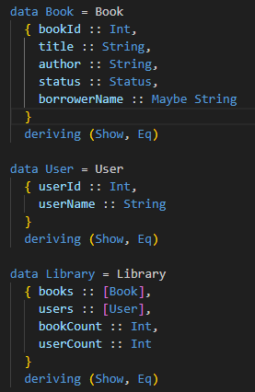

Pure Functions
Pure functions in Haskell are functions that consistently perform the same operation for the same input. For instance, the add book method will always add a book to the provided library and return the modified library. These functions will never perform IO-related operations.

Figure 3. Illustration of code base section displaying pure function

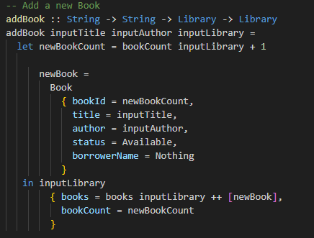
The above function takes title, author, and a library instance as arguments. The book ID will be computed by incrementing the previous book count by 1, and the resulting value will be assigned to both the library's new count and the book ID. The new book will be concatenated to the existing list of books in the Library. Additionally, allowing the user to be recorded in the system once they have borrowed a book.

Higher-Order Functions
An example of a higher-order function in the project is printBook, which calls itself recursively by iterating over each item in the book list and passing the remaining items to itself.

Figure 4. Illustration of a codebase section displaying a higher-order function

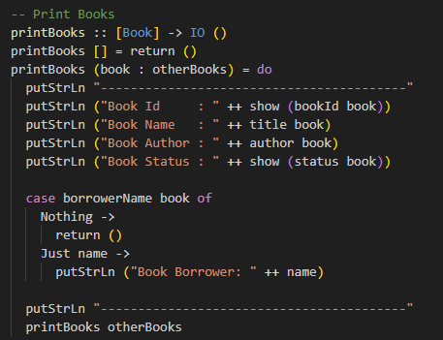

Testing Phase
During the test phase, all critical functions are tested with all possible inputs/scenarios, and their outputs are validated by comparing them to expectations. The following tests are created for testing add / remove – book/user.

Test Approach and Scenario Coverage
The testing strategy focused on verifying both the correctness and robustness of the library management system. Unit tests, integration tests, and edge-case validation were conducted to ensure all functional aspects operate as intended. Special attention was given to operations that alter state, such as borrowing and returning books, to ensure immutability and consistency are preserved.

Book/User Management Tests
Unit tests were designed to confirm the functionality of adding and removing books and users, and to ensure accurate ID assignment and validation.
Sample tests include:
Methods | Functionality
testAddOneBook + testAddTwoBook | validates book addition logic.
testRemoveBook + testRemoveBookInvalid | Checks correct removal and error handling
testAddOneUser + testAddTwoUser | Verifies user addition
testRemoveUser + testRemoveUserInvalid | Validates user removal and constraints.

Borrow/Return Transaction Tests
Borrowing and returning books involve complex logic, including book status validation, user verification, and error messaging.
Key tests include:
Methods | Functionality
testBorrowBookWithValidUser | Confirms successful borrow transactions.
testBorrowBookWithInvalidUser + testBorrowBookWithInvalidBook | Verifies error handling
testBorrowBookWithAlreadyBorrowedBook | Prevents Duplicate Borrowing
testReturnBookWithValidUser | Adds an invalid case to ensure status update and error handling

Summary of Observed Behaviours
All tests confirmed that the system handles both typical and edge-case scenarios correctly. Data integrity is maintained, and all functions exhibit deterministic behaviour, demonstrating adherence to functional programming principles.

Critical Review

Strengths:

Designing software with strong modularity and clean architecture.
By separating my system’s logic (Library.hs) from the CLI interface (Main.hs), I demonstrated a clear understanding of how to structure programs that are maintainable, scalable, and easy to extend.

Ensuring robust validation and reliability in my code.
In my borrow-and-return logic, I carefully verify that the book ID is valid, ensure the book is not already borrowed, and check that the user ID exists before completing an operation. This level of validation demonstrates my commitment to building safe, dependable functionality.

Thoroughly testing my systems to ensure correctness.
I performed extensive unit testing across all major use cases—book operations, user operations, borrowing, and returning. This demonstrates my focus on reliability, error prevention, and producing code that behaves correctly under different scenarios.

Applying functional programming principles effectively.
Throughout the project, I utilised immutability, pure functions, higher-order functions, and modular design, showing strong proficiency in functional programming concepts and their practical application in Haskell.
Figure 4. Illustration of code base section displaying the following:
If the book ID is valid or not
If the book is already borrowed or not
If the user ID is valid or not

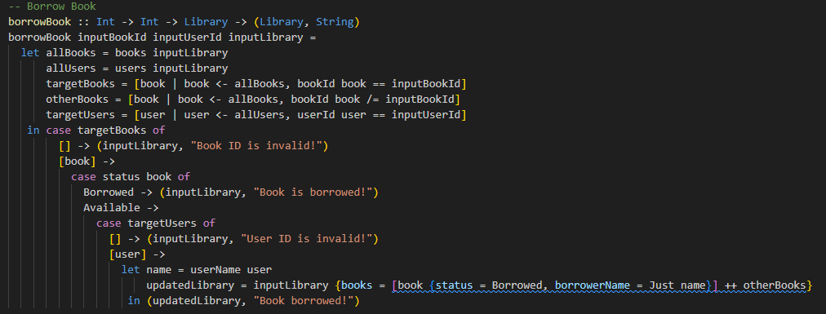

Unit testing has been performed extensively, covering all use cases for the core methods.

Areas of Improvement:

1. Implement data persistence so the system can retain information across sessions.
Right now, the library’s data exists only while the application is running. I recognise that I should store this information in a persistent format, such as CSV or another file type. Therefore, users don’t have to keep the application open to preserve their data.
2. Improve how user–book relationships are modelled.
Although my current system tracks the user associated with a borrowed book, I could strengthen the design by also maintaining a list of book IDs within each user object. This would create a more complete and efficient representation of borrowing activity.
3. Enhance the user interface and overall modularity of the system.
The system currently uses a simple CLI, but introducing a graphical user interface would significantly improve the user experience. While doing this, I can further modularise the library by adding new modules, refining the existing structure, and improving how user input is parsed through the UI.

Conclusion
I used Haskell to create a modular and extensible library management system for this project, which improved my architectural thinking and showed my dedication to scalable, clean software design. I gained a better grasp of how to design maintainable and future-proof systems by isolating the command-line interface from the essential business logic. This division of responsibilities strengthened modularity, increased clarity, and emphasised the value of creating adaptable software. In addition to managing dynamic collections of books and users and supporting basic functions like borrowing, returning, and listing resources, the system verifies structured user input. To guarantee consistent and dependable behaviour, functional programming concepts such as immutability, pure functions, higher-order functions, and strong static typing were used throughout. Before carrying out operations, book IDs, user IDs, and borrowing states were checked as part of the emphasis on validation. My ability to design dependable and testable code was further strengthened by the creation of thorough unit tests that covered all significant scenarios. The initiative also identified areas that needed development, such as improving the data model and putting in place persistent storage. All things considered, this experience improved my technical abilities and professional outlook, laying a solid basis for my future academic and software development endeavours.

Estimated Grade:

Functional Principles: A+
This grade is justified by the consistent and effective application of functional programming concepts, including immutability, pure functions, higher-order functions, and strong type safety. The system demonstrates clear modularity, reliable validation, and comprehensive automated testing across all core operations, meeting and exceeding the functional requirements outlined in the assessment brief.
Report: A
The report is clearly structured, well-written, and demonstrates strong technical understanding supported by relevant code examples, testing evidence, and critical reflection. Minor improvements could be made in refining references and expanding discussion on future scalability; however, the report meets the criteria for clarity, depth, and professional presentation.

References
This report and the related code were created without the assistance of any generative AI tools other than spelling and grammar checkers, in compliance with the assessment brief. This submission's design choices, implementation, testing, and analysis are all original to me and are based on independent research, lab materials, and module lectures.

Newb (2013). Haskell String-> Int Type Conversion. [online] Stack Overflow. Available at: https://stackoverflow.com/questions/20667478/haskell-string-int-type-conversion.
Bird, R.S., Gibbons, J. and Cambridge University Press (2020). Algorithm design with Haskell. Cambridge ; New York ; Port Melbourne ; New Delhi ; Singapore: Cambridge University Press.
Sannella, D., Fourman, M., Peng, H. and Wadler, P. (2022). Introduction to Computation. Springer Nature.
Hutton, G. and Cambridge University Press (2018). Programming in Haskell. Cambridge: Cambridge University Press.
Newb (2013). Haskell String-> Int Type Conversion. [online] Stack Overflow. Available at: https://stackoverflow.com/questions/20667478/haskell-string-int-type-conversion.
Haskell Community (2023). Simple newbie-friendly CLI parser? [online] Haskell Community. Available at: https://discourse.haskell.org/t/simple-newbie-friendly-cli-parser/6228/6.
Hutton, G. (2011). Programming in Haskell. Cambridge: Cambridge University Press.
Kurt, W. (2018). Get programming with Haskell. Shelter Island, Ny Manning.
Tirronen, V., Uusi-Mäkelä, S. and Isomöttönen, V. (2015). Understanding beginners’ mistakes with Haskell. Journal of Functional Programming, [online] 25. doi:https://doi.org/10.1017/S0956796815000179.
Vitaly Bragilevsky (2021). Haskell in Depth. Simon and Schuster.
Wadler, P. (1992). The essence of functional programming. Proceedings of the 19th ACM SIGPLAN-SIGACT symposium on Principles of programming languages - POPL ’92. doi:https://doi.org/10.1145/143165.143169.
A J T Davie (1992). An introduction to functional programming systems using Haskell. Cambridge; New York, Ny, Usa: Cambridge University Press.
Bird, R. (1998). Introduction to Functional Programming Using Haskell. Pearson Educación.
Bossard, A. (2020). A Gentle Introduction to Functional Programming in English [Third Edition]. 株式会社 オーム社.
Stefania Loredana Nita and Marius Mihailescu (2019). Haskell Quick Syntax Reference. Apress.
Million Formula (2025). Understanding Functional Programming in Haskell. [online] DEV Community. Available at: https://dev.to/million_formula_3be3d915d/understanding-functional-programming-in-haskell-38jo [Accessed 25 Nov. 2025].
Haskell.org. (2016). Tutorials - HaskellWiki. [online] Available at: https://wiki.haskell.org/Tutorials [Accessed 25 Nov. 2025].
GeeksforGeeks (2022). What is Haskell Programming Language? [online] GeeksforGeeks. Available at: https://www.geeksforgeeks.org/blogs/what-is-haskell-programming-language/.
asciiflow.com. (n.d.). ASCIIFlow. [online] Available at: https://asciiflow.com/#/.

**All coding practice and additional knowledge demonstrated in this final assessment have been sourced from the University of Brighton: CI504 Introduction to Functional Programming Lab Practice and Lecture Notes**

